Technical Documentation
JMS Connector
<Document Code e.g. XXXXX>

Document Information

General
Document Title: | Technical Documentation
Area or Project: | JMS Connector
Document Code: | <Document Code e.g. XXXXX>
Document Owner: | Gert Smits
File Name | 0000.doc
.
History
Version | Date | Status | Author | Affected pages: | Approved by:
v1, | 2006-09-12 | New | Gert Smits | All

Distribution
Version | Name | Date | Publication Status
v1

Copyright © 2006 by Cordys Corporation B.V. (“Cordys”). All rights reserved; subject to limited distribution and restricted disclosure only.
Cordys Integrator, Cordys Orchestrator, Cordys Studio, and Cordys Portal are trademarks of Cordys Systems B.V.
All other trademarks mentioned herein maybe/are the trademarks or registered trademarks of their respective owners and should be noted as such.
The information in this document is confidential, constitutes the proprietary property of Cordys, and is protected by copyright laws and international copyright treaties. No part of this document may be reproduced or transmitted in any form or by any means, electronic or mechanical, for any purpose, without the express written permission of Cordys. The information contained in this document is subject to change without notice. Cordys does not warrant that the information contained in this document is error free. Cordys assumes no liability for any damages incurred, directly or indirectly, from any errors, omissions, or discrepancies between the software and the information contained in this document.
TABLE OF CONTENT
1. Introduction 5
1.1 Content 5
1.2 Audience 5
1.3 Purpose 5
1.4 Definitions, acronyms, and abbreviations 5
1.5 References 5
2. Overview 6
2.1 Introduction 6
2.2 Assumptions and Limitations 6
2.3 Cordys Connectors Framework 6
2.4 General Connector Architecture 6
2.5 General Connector Configuration 6
3. Architecture 7
3.1 Concepts and Definitions of Messaging 7
3.2 Architecture 8
3.2.1 Static View 8
3.2.2 Deployment View 9
3.3 Types, Classes and Objects 10
3.3.1 Java 10
3.3.2 Configuration page 11
3.4 Collaborations 11
3.4.1 Initialization 11
3.4.2 Shutdown 13
3.4.3 Configuration 13
3.4.4 Send asynchronous messages 13
3.4.5 Receive messages 14
3.4.6 Send and receive synchronous request 14
3.4.7 Triggers of asynchronous reply 15
3.4.8 Closing the JMS Connector 16
4. Component Description 18
4.1 User Interface 18
4.2 Java Classes 18
4.2.1 JMSConnector 18
4.2.2 JMSConnectorTransaction 19
4.2.3 DestinationManager 19
4.2.4 Class: Destination 20
4.2.5 Trigger 21
4.2.6 JMSConnectionPoller 21
4.2.7 JMSConnectionProblemResolver 22
4.2.8 JMSConnectorConfiguration 23
4.2.9 JMSUtil 23
4.2.10 JMSConfigurationException 24
4.2.11 JMSConnectorException 25
4.2.12 LogMessages 25
4.3 Configuration Files 26
4.3.1 File “com.cordys.coe.ac.jmsconnector.JMSConnector” 26
4.3.2 Multiple ISV configuration Files 26
4.3.3 File “Cordys.CoE.JMSConnector.LogMessages.xml” 27
4.3.4 File “Method Set JMS Connection.xml” 27
4.3.5 Studio Files 28
4.3.6 Web Files 28
4.4 Dependencies on external Jar files 28
4.5 How to work with JMS providers such as IBM or others 28
5. Details 29
5.1 Organization of the source files 29
5.2 Organization of the class files 29
5.3 Organization of the user interface 29
5.4 Organization of the configuration files 29
5.5 Organization of the installer files?? 29
5.6 Exception handling 29
5.7 How to build the Connector 29
5.8 How does deployment work 29
5.9 Installing and configuring the connector 29
5.10 Debugging the Connector 29
5.11 Known problems 29
5.12 Do’s and Don’ts 29
6. Using the JMS Connector 30
6.1 Method sendMessage 30
6.2 Method getMessage 30
6.3 Method requestMessage 30

- Introduction

Content

Audience

Purpose
- for the planning and team development activities.

Definitions, acronyms, and abbreviations
Term | Description

References
Code | Description
JMSTUTORIAL | Java™ Message Service API Tutorial

- Overview

Introduction
The Cordys JMS Connector allows connecting Cordys components (e.g. SOAP processors) with external applications, using MQ connectivity. Many companies have used WebSphere MQ to provide connectivity and openness across their own heterogonous set of backend systems and often function as their communication bus. How viable this integration strategy may be most companies noticed that the orchestration of the business logic is shattered across systems and is often implemented in the routing mechanisms of WebSphere MQ. Using the Cordys JMS Connector, it is possible to provide orchestration in a transparent and easy to maintain form using Cordys Studio for defining the orchestration across backend systems and using Cordys JMS Connector to interact with those backend systems using the existing WebSphere MQ connectivity build into those backend systems.

Assumptions and Limitations
The JMS Connector is build using the JMS standard and the JMS vendor specific libraries. This means that many vendor specific possibilities which are not specified in the JMS standard will not be possible.

Cordys Connectors Framework
The JMS Connector is built using the standard connector framework and thus providing optimal connectivity to the Cordys ESB.

General Connector Configuration
The Configuration pages which are part of the JMS Connector product are part of the standard Cordys connector framework. Only the JMS configuration page belongs to the JMS Connector itself and is part of its build definition (using the build framework).
- Architecture (Java)

Concepts and Definitions of Messaging
(Definitions are partly taken from the JMS Tutorial of Sun).

Destination
A destination is the object a client uses to specify the target of messages it produces and the source of messages it consumes. In the Point-to-Point messaging domain, destinations are called queues

Queue
A point-to-point product or application can be built around the concept of message queues, senders, and receivers. Each message is addressed to a specific queue, and receiving clients extract messages from the queue(s) established to hold their messages.

Connections
A connection encapsulates a virtual connection with a JMS provider. A connection could represent an open TCP/IP socket between a client and a provider service daemon. You use a connection to create one or more sessions.

Sessions
A session is a single-threaded context for producing and consuming messages. You use sessions to create message producers, message consumers, and messages. Sessions serialize the execution of message listeners.
A session provides a transactional context with which to group a set of sends and receives into an atomic unit of work.

Message producers
A message producer is an object created by a session and is used for sending messages to a destination.

Message consumers
A message consumer is an object created by a session and is used for receiving messages sent to a destination. A message consumer allows a JMS client to register interest in a destination with a JMS provider. The JMS provider manages the delivery of messages from a destination to the registered consumers of the destination.

Message listeners
A message listener is an object that acts as an asynchronous event handler for messages.

Messages
The ultimate purpose of a JMS application is to produce and to consume messages that can then be used by other software applications. JMS messages have a basic format that is simple but highly flexible, allowing you to create messages that match formats used by non-JMS applications on heterogeneous platforms.
A JMS message has three parts:
- A header
- Properties (optional)
- A body (optional)

Architecture

Static View
The JMS connector consists of three packages, namely
- Package com.cordys.coe.ac.jmsconnector
- Package com.cordys.coe.ac.jmsconnector.exceptions
- Package com.cordys.coe.ac.jmsconnector.messages
The first package, com.cordys.coe.ac.jmsconnector, contains the main connector logic and is depicted in the following diagram.
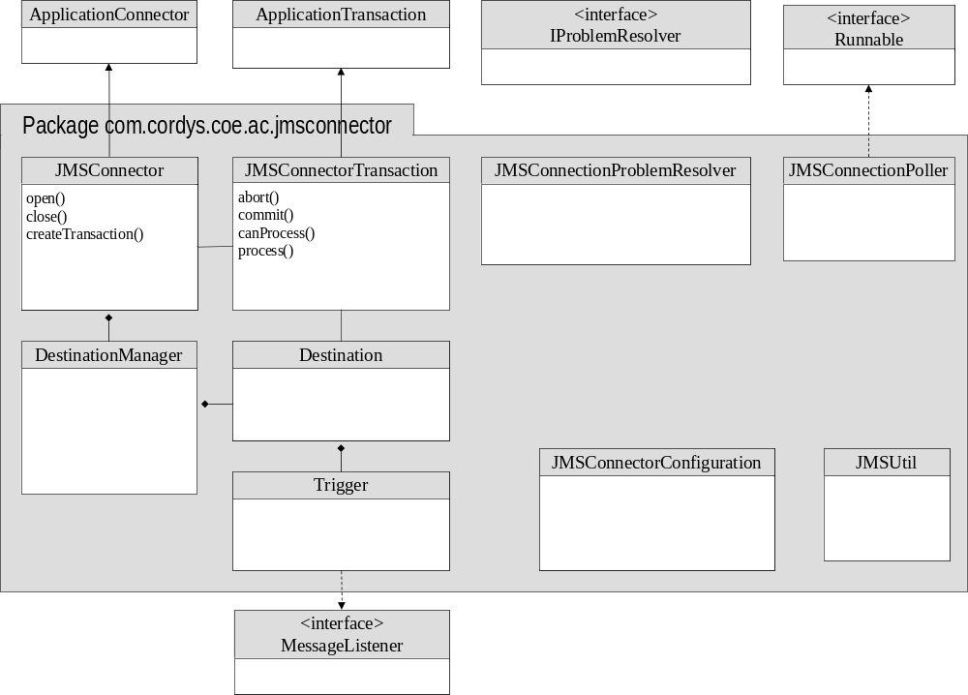
Figure 1: class diagram of JMC Connector

Because the JMS connector is based on the Cordys Connector technology, it needs two classes which inherit from the standard classes ApplicationConnector and ApplicationTransaction.
Each of the classes is described in later sections, but a short characterization is given below:
- The JMSConnector class represents the application connector and is the entry point for the soap processor and bus for interacting with the application connector
- The JMSConnectorTransaction class is the class which instances are responsible for handling an individual soap request and returning the reply.
- The DestinationManager class represents the external queue manager and is responsible managing the queues.
- The Destination class represents the external queue and handles the interaction with this queue.
- The Trigger class is used when incoming messages should invoke a soap method automatically. The Trigger class is registered as a callback of type MessageListener.
- The JMSConnectionPoller class is responsible for periodically checking the DestinationManager for lost connections and restart if the connection was lost.
- The JMSUtil class contains a set of supportive (static) methods used by the other classes.
- The JMSConnectionProblemSolver class is part of the Cordys framework and is in this connector used to deal with situations where the connection is lost.
- The JMSConnectorConfiguration class is used to hold configurable properties of the connector.

Deployment View
The following figure shows how the JMS Connector functions during runtime.

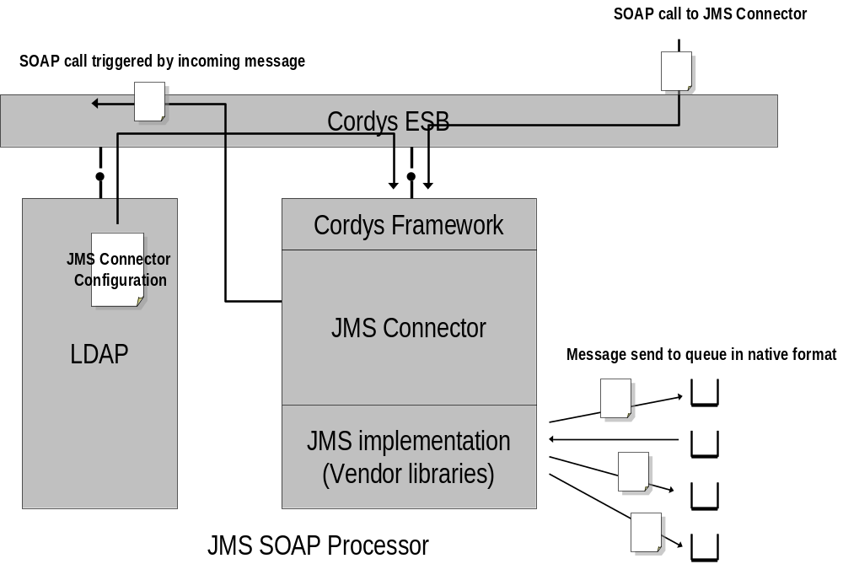
Figure 2: Deployment diagram of the JMS Connector

The JMS Connector bridges two worlds: the Cordys ESB world with many services communicating using SOAP messages, and the MOM world, using their own proprietary message formats and protocols. The other ESB services send SOAP methods to the JMS Connector or receive SOAP message from the JMS Connector. The JMS Connector will transform SOAP messages to and from the native MOM format.
In principle, one JMS Connector SOAP processor can handle many queue managers and queues.
The configuration of the JMS Connector (about which Destination Managers, Destinations, Message Transformations and Triggers) is stored in LDAP.

Types, Classes and Objects

Java

Data structures
During the execution of the program, the following data structures are built (see figure below):
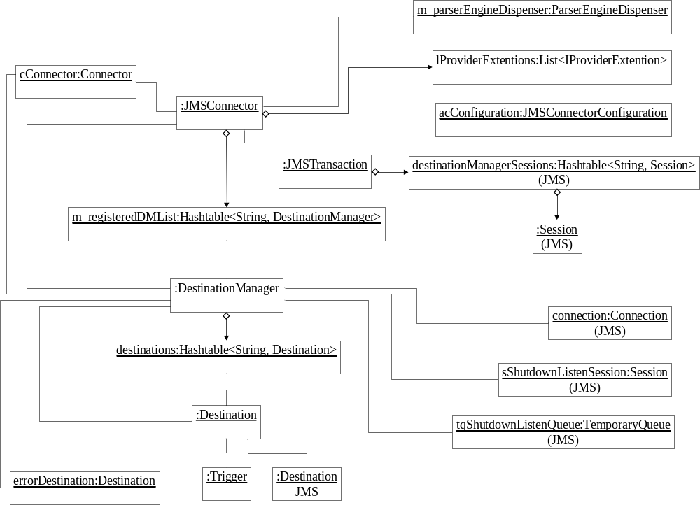
Figure 3: The connector data structures

This figure does only show the most important data structures, especially the collections used to support the sending and receiving messages.
A number of the JMS objects (e.g. Session objects) are created as part of the JMSTransaction scope.
The Session is associated with DestinationManager via the key in the Hashtable destinationManagerSessions.
Per Destination objects, Producer and Consumer objects are created within the scope of the call.
A connector Destination object is one to one related to a JMS Destination object.
To create Session objects, the Connection object, managed by the DestinationManager, is used.

Configuration page

Collaborations

Initialization

Main flow of initialization
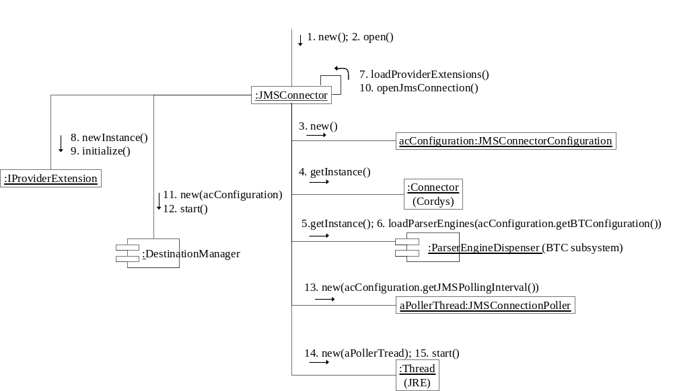
Figure 4: Initialization of JMS Connector (Main flow)

During initialization the following steps are taken:
- Create an instance from the JMSConnector class.
- Create an instance acConfiguration from the JMSConnectorConfiguration. Part of this object is the configuration data where the BTC definition files are stored.
- Get an instance from the class Connector to be used to send messages to the bus (other services).
- Get an instance of the class ParserEngineDispenser. This is part of the BTC engine. Using this instance the BTC definition files can be loaded.
- Call loadProviderExtensions() to deal with the use of JMS vendor specific features. For example, setting the Message ID field for WebSphere MQ.
- Call OpenJmsConnection(), which will create all destination managers and destinations (detailed in a next diagram) as defined in the connector configuration and than starts all destination managers.
- An object aPollerThread from class JMSConnectionPoller is instantiated
- A Thread object is created and associated with the aPollerTread object and the thread is started.

Initialization of the Destination Managers and Destinations
The following diagram depicts how, from the level of the DestinationManager, the initialization is done.
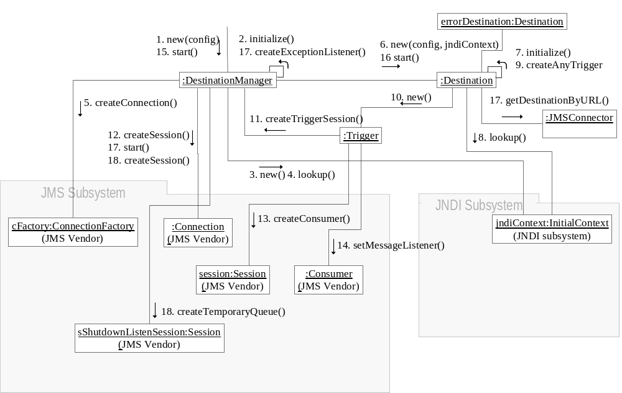
Figure 5: Initialization of JMS Connector (details on destinations)

The initialization consists of two phases:
- In the first phase, the objects are created, initiated by the new() operation on the class DestionationManager().
- The second phase begins with the operation start() on the instance of the class DestinationManager(). This step will create relations between existing objects.

Phase 1:
Phase 1 is started by the creation of the DestinationManager. During the steps of the initialization, JNDI is first used to acquire handles to the real implementation factories and objects and next those factories and objects are used to connect to the underlying message infrastructure. After doing this for the DestinationManager the same is done for each Destination, as defined in the connection configuration. Each Destination instance gets a handle to a JMS javax.jms.Destination instance, using JNDI.
In case that a destination has the ability to trigger an action based on an incoming message, also a Trigger object is created. Contrary to the DestinationManager and Destination objects, in this stage the Trigger objects already receive an instance of a Session and Consumer class.

Phase 2:
In phase 2, associations between Destination objects are created. For each Destination object, another Destination object can act as the error destination. When a message cannot be delivered as intended, the message is send to the error destination.
Finally, for the DestinationManager, an ExceptionListener is created. When an application reads or writes from queues, failure of the message infrastructure is automatically detected. However, when passively listening for messages, failure is not detected, and the ExceptionListener is used to detect this.

Shutdown

Configuration
Describe how the method definition is used
Describe how the configuration page data is used

Send asynchronous messages
The following diagram depicts how a message is sent to the queue.
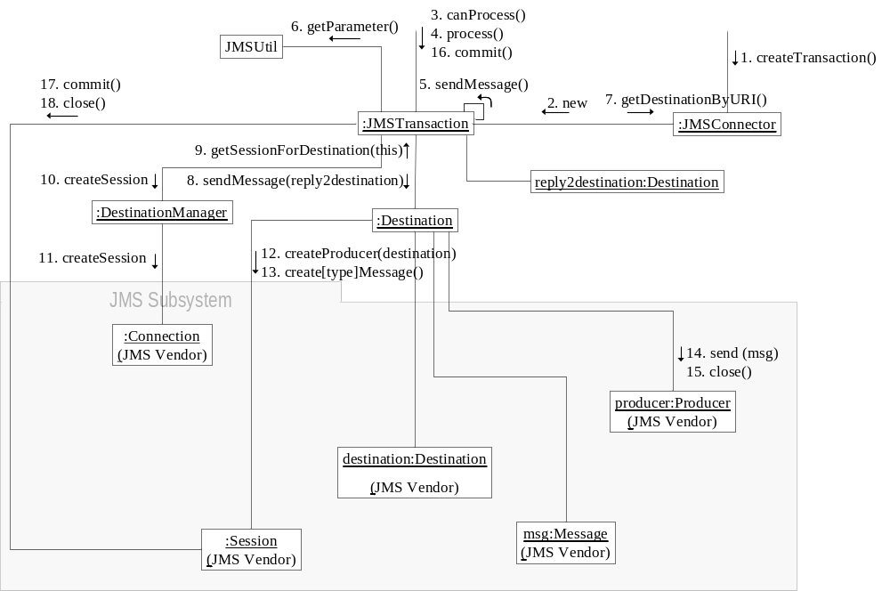
Figure 6: Sending a message asynchronous

Each incoming SOAP method in a standard connector is handled following the same pattern. First the framework request for a transaction object from the JMSConnector and an instance of JMSTransaction is returned.
The next step is that the framework first asks from the JMSTransaction object if it can handle the request of type “JMSCONNECTOR”. If so, the method process() is invoked and the main part of the work will be started.
The following step is preparing the sending of the actual message, done by

Receive messages
The following figure depicts the process of receiving a message actively, by polling for the message. This can be done by waiting until a message is received or by immediately returning if no message is found.
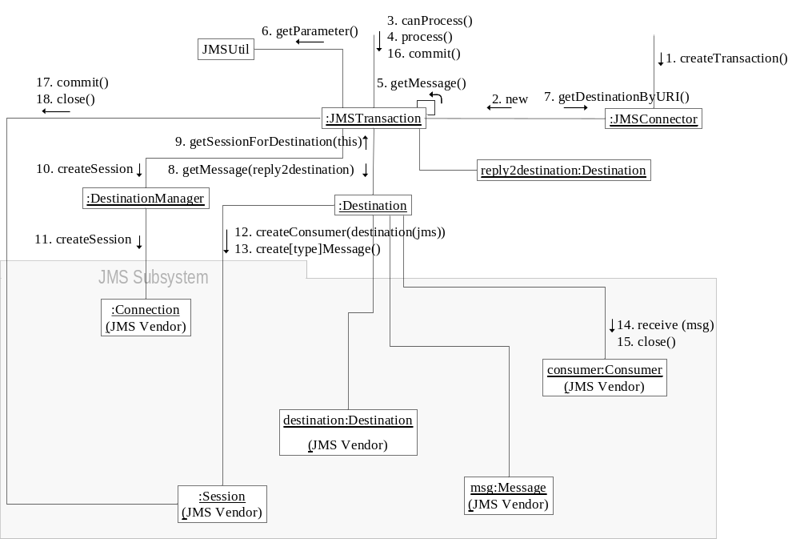
Figure 7: Receiving messages

When actively receiving messages, one has a choice of reading any message or reading messages, based on the correlation ID.

Send and receive synchronous request
The following figure depicts the synchronous sending and receiving of messages:
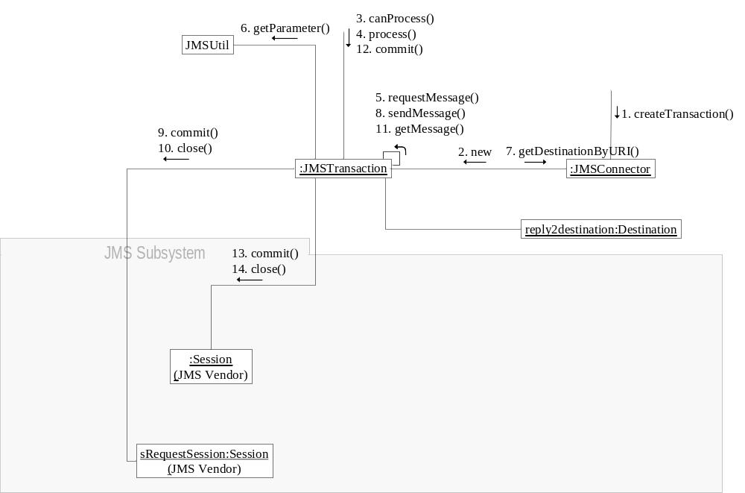
Figure 8: Sending and receiving of messages

This method is implemented reusing the sendMessage() and getMessage() method.
It is important that to make sure the messages are actually sent, the Session used to send the message is committed (and closed).

Triggers of asynchronous reply
The following figure depicts how the connector will get triggered on the arrival of messages.
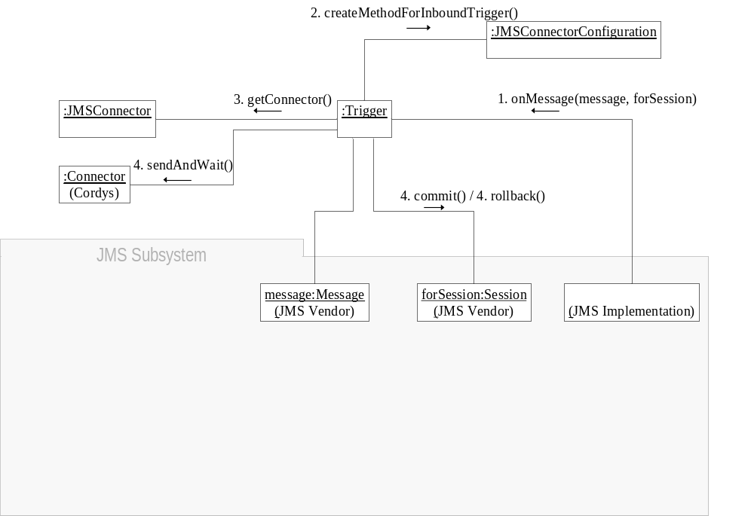
Figure 9: Triggering on arrival of messages

When the Trigger object was created, also a JMS Session (and Consumer) objects was created. When the onMessage() method triggers, this Session object is passed in the forSession parameter.
The next steps are:
- Creating a method, as specified in the configuration object, to be send to the ESB by calling the method createMethodForInboundTrigger().
- Getting an handle to a Cordys Connector class via the JMSConnector object
- Sending the message by calling sendAndWait() method on the Connection object.
- Commit the Session

Shutdown the JMS Connector
The following figure depicts the sequence of actions when the connector receives the close method from the Connector framework.
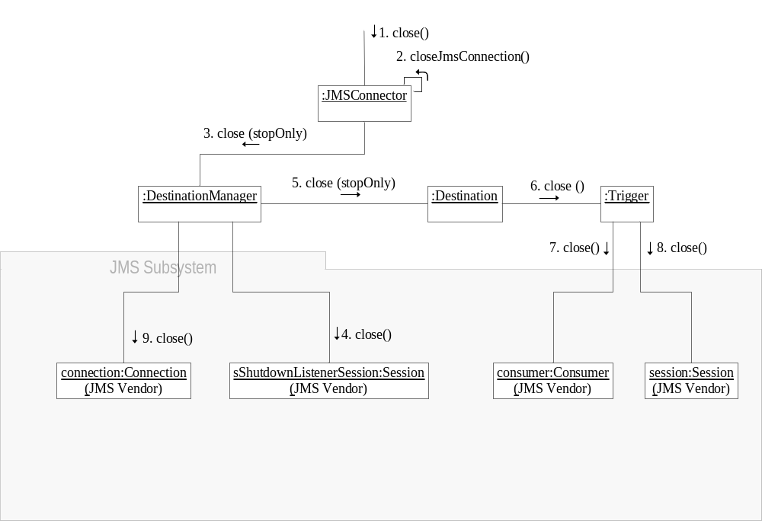
Figure 10: Closing the JMS Connector

Although most of the JMS objects are allocated dynamically when sending and receiving messages, a number of statically allocated JMS objects have to be closed. Especially for the Trigger object, the Session and Provider objects have to be removed as well as the Connection object per DestinationManager object.

Reconnect of the connector
If the JMS Connector loses its connections from the underlying MQ infrastructure when this is temporarily not available, it is important that the JMS Connector will automatically reconnect when the MQ infrastructure becomes available again. This can happen when for maintenance the MQ server is rebooted.
During the start() method of the DestinationManager object a listener is created on a temporary queue (variable: tqShutdownListenQueue) to be used by JMS to notify the applications that the MQ infrastructure is unavailable. The listener is created by creating object from an inner class ExceptionListener and defining the onException() method. The method handleJmsException() of the outer class DestinationManager handles the event.
The result of handling this event is that the connection of the DestinationManager object with the lost connection is set to null.
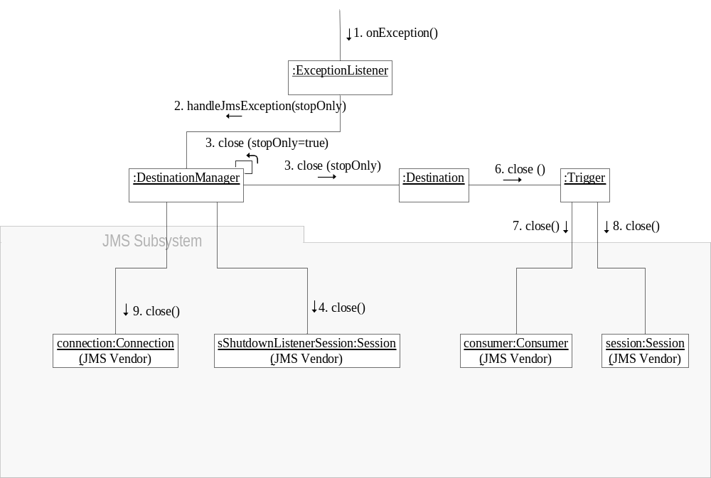
Figure 11: Reacton on losing connection with MQ

The object of class JMSConnectionPoller will at intervals check the connections of all the DestinationManager and when one the connection has value null, try to restart the connection using the restart() method on the DestinationManager objects. The restart() method follows almost the same flow as the initialization except that no lookups of destinations are needed.
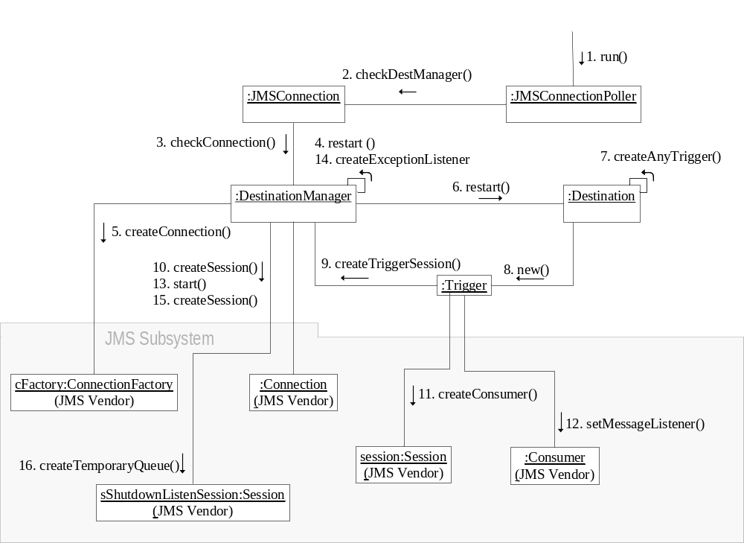
Figure 12: Reconnecting the JMS Connector to the MQ infrastructure

Exception handling

- Binary Transformation Channel

Overview
When reading and writing to and from destinations, it can be necessary to transform the data from on structure to the other structure. For example, the information on the queue can be in a non XML format. This transformation is transparently performed in the Destination class methods sendMessage() and getMessage(). The parameter which controls the use of the BTC ParserEngine class for transformation is the Destination object attribute btcProtocol or the messageFormat attribute passed with the message itself.

Short description of BTC
The working of the Binary Transformation Channel is described in the Cordys Platform documentation. This section gives a very brief overview of its working.

Transforming the message
In principle, the BTC engine transform from XML to a external (binary) format and from a external to an XML format
[ HERE A FIGURE OF THE WHOLE MESSAGE]

Transforming the attributes

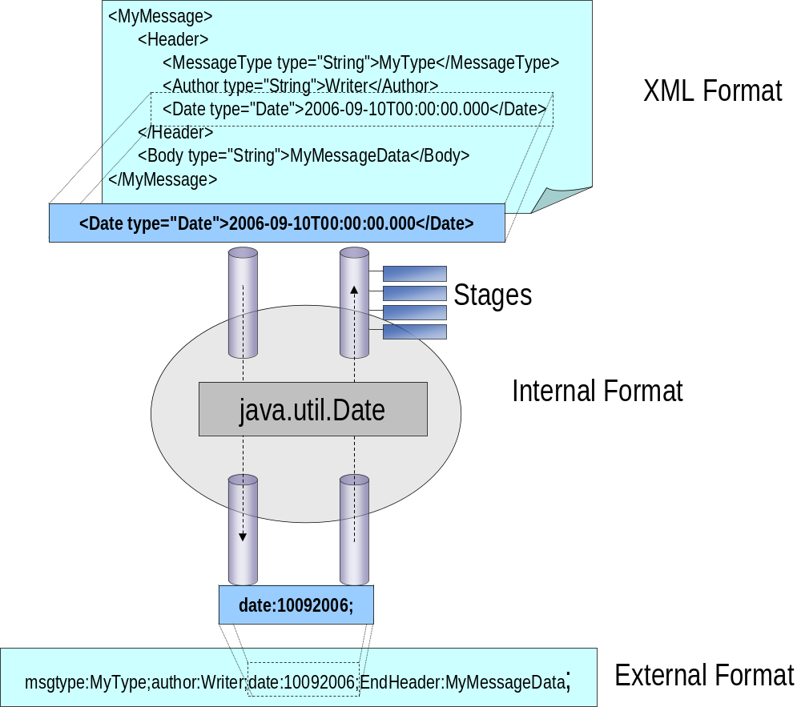
Figure 13: BTC Engine transforming an attribute of the message.

- User Interface

Models
GetOrganizationalUsersModel
DestinationConfigurationModel
MessageTriggerModel
MainConfigModel
GetOrganizationsModel

Describe relations between models, methods and script functions
- Component Description

Java Classes
Location of java files is: src\java
Location of class files is: classes

JMSConnector

Overview
Attributes
Class: | JMSConnector
Package: | com.cordys.coe.ac.jmsconnector
Description:

Responsibilities and Collaborations
Responsibility | Component: JMSConnector |  | Collaboration
Initiates the application connector |  | Soap processor framework
Shutdown of the application connector |  | idem
Create a connection to the bus for callback functions |  | Idem
Initiate the BTC logic |  | Idem
Gets the application connector configuration data |  | Idem
Initializes the DestinationManagers (creating connections to queues) |  | DestinationManager class
Stop the DestinationManagers (and the connections to the queues) |  | DestinationManager class
Initializes the JMSConnectionPoller |  | JMSConnectionPoller class
Entry point to get an instance of the class JMSConnectorTransaction |  | JMSConnectorTransaction class

Interface
Function | Arguments

Implementation Detail
None

JMSConnectorTransaction

Overview
Attributes
Class: | JMSConnectorTransaction.java
Package: | com.cordys.coe.ac.jmsconnector
Description:

Responsibilities and Collaborations
Responsibility | Component: JMSConnectorTransaction |  | Collaboration
Checks if the request can be processed
Commits or aborts the transaction
Processes the request

Interface
Function | Arguments

Implementation Detail
None

DestinationManager

Overview
Attributes
Class: | DestinationManager.java
Package: | com.cordys.coe.ac.jmsconnector
Description:

Responsibilities and Collaborations
Responsibility | Component: DestinationManager |  | Collaboration

Interface
Function | Arguments

Implementation Detail
None

Class: Destination

Overview
Attributes
Class: | Destination.java
Package: | com.cordys.coe.ac.jmsconnector
Description:

Responsibilities and Collaborations
Responsibility | Component: Destination |  | Collaboration

Interface
Function | Arguments

Implementation Detail
None

Trigger

Overview
Attributes
Class: | Trigger.java
Package: | com.cordys.coe.ac.jmsconnector
Description:

Responsibilities and Collaborations
Responsibility | Component: Trigger |  | Collaboration

Interface
Function | Arguments

Implementation Detail
None

JMSConnectionPoller

Overview
Attributes
Class: | JMSConnectionPoller.java
Package: | com.cordys.coe.ac.jmsconnector
Description:

Responsibilities and Collaborations
Responsibility | Component: JMSConnectionPoller |  | Collaboration

Interface
Function | Arguments

Implementation Detail
None

JMSConnectionProblemResolver

Overview
Attributes
Class: | JMSConnectionProblemResolver.java
Package: | com.cordys.coe.ac.jmsconnector
Description:

Responsibilities and Collaborations
Responsibility | Component: JMSConnectionProblemResolver |  | Collaboration

Interface
Function | Arguments

Implementation Detail
None

JMSConnectorConfiguration

Overview
Attributes
Class: | JMSConnectorConfiguration.java
Package: | com.cordys.coe.ac.jmsconnector
Description:

Responsibilities and Collaborations
Responsibility | Component: JMSConnectorConfiguration |  | Collaboration

Interface
Function | Arguments

Implementation Detail
None

JMSUtil

Overview
Attributes
Class: | JMSUtil.java
Package: | com.cordys.coe.ac.jmsconnector
Description:

Responsibilities and Collaborations
Responsibility | Component: JMSUtil |  | Collaboration

Interface
Function | Arguments

Implementation Detail
None

JMSConfigurationException

Overview
Attributes
Class: | JMSConfigurationException.java
Package: | com.cordys.coe.ac.jmsconnector.exceptions
Description:

Responsibilities and Collaborations
Responsibility | Component: JMSConfigurationException |  | Collaboration

Interface
Function | Arguments

Implementation Detail
None

JMSConnectorException

Overview
Attributes
Class: | JMSConnectorException.java
Package: | com.cordys.coe.ac.jmsconnector.exceptions
Description:

Responsibilities and Collaborations
Responsibility | Component: JMSConnectorException |  | Collaboration

Interface
Function | Arguments

Implementation Detail
None

LogMessages

Overview
Attributes
Class: | LogMessages.java
Package: | com.cordys.coe.ac.jmsconnector.messages
Description:

Responsibilities and Collaborations
Responsibility | Component: LogMessages |  | Collaboration

Interface
Function | Arguments

Implementation Detail
None

Configuration Files

File “com.cordys.coe.ac.jmsconnector.JMSConnector”

Overview
Attributes
File: | com.cordys.coe.ac.jmsconnector.JMSConnector
Development time Directory: | src\content\applicationconnectors
Runtime Directory:
Description:

Multiple ISV configuration Files

Overview
Attributes
Files: | ApplicationConnector.xml  CoBOC.xml  FileSystem.xml  Localizations.xml  Menus.xml  Methodsets.xml  Prompts.xml  Roles.xml  Studio.xml  Styles.xml  SystemEnvironment.xml  Toolbars.xml  WsAppServer.xml  XForms.xml  XMLStore.xml
Development time Directory: | src\content\isv
Runtime Directory:
Description:

File “Cordys.CoE.JMSConnector.LogMessages.xml”

Overview
Attributes
File: | Cordys.CoE.JMSConnector.LogMessages.xml
Development time Directory: | src\content\logging
Runtime Directory:
Description:

File “Method Set JMS Connection.xml”

Overview
Attributes
File: | Method Set JMS Connection.xml
Development time Directory: | src\content\methodsets
Runtime Directory:
Description:

Studio Files

Overview
Attributes
File: | JMSConnectorConfig.caf  JMSConnectorConfig2.caf  GenerateMethods.caf
Development time Directory: | src\content\studio\xforms
Runtime Directory:
Description:

Web Files

Overview
Attributes
File: | jmsconnector.htm  coelib.js????
Development time Directory: | src\web
Runtime Directory:
Description:

Dependencies on external Jar files

How to work with JMS providers such as IBM or others

- Details

Organization of the source files

Organization of the class files

Organization of the user interface

Organization of the configuration files

Organization of the installer files??

Exception handling

How to build the Connector

How does deployment work
How is the development content moved to the runtime content and when and by whom.

Installing and configuring the connector
See document of Karel Ekema

Debugging the Connector

Known problems

Do’s and Don’ts

- Using the JMS Connector

Method sendMessage
The method sendMessage will asynchronously send a message to a queue.
The following properties can be set:

<messageformat>
The messageformat is either empty or “base64”
<messagetype>
The messagetype is empty or “bytes”

Method getMessage
The method getMessage will pull messages from the queue.

<messageformat>
The messageformat is empty, “base64”, “xml” or “xmlMessage”
<messagetype>
The messagetype is empty or “bytes”

REMARK: “BYTES” not yet tested

Method requestMessage
<messageformat>
The messageformat is empty or “base64”

<responsemessageformat>
The responsemessageformat is empty, “base64”, “xml” or “xmlMessage”

<messagetype>
The messagetype is empty or “bytes”

